Joint CQSE & NCTS Seminar

2024
Oct. 4, Friday

Time: Oct. 4, 14:20 ~ 16:20
Title: Quantum-inspired Vehicle Routing Scheme for Rebalancing in Bike
Sharing Systems
Speaker: 歐家和教授兼資訊學院院長 (國立屏東大學資訊工程學系)
Place: Rm. 104, Chin-Pao Yang Lecture Hall, Department of Physics/CCMS, NTU
Online Link: https://nationaltaiwanuniversity-zbh.my.webex.com/nationaltaiwanuniversity-zbh.my/j.php?MTID=m7601bdfa496ccaf8aac2838aab8c25f2

Abstract:
Bike sharing systems are gaining popularity worldwide, and with the rise of global warming, they have become even more critical for reducing greenhouse gas emissions in cities. One of the key operations of a bike sharing system is rebalancing, which involves maintaining the number of bikes at each station to a target value by arranging vehicle loading and unloading operations. This paper proposes a quantum-inspired vehicle routing scheme to solve the rebalancing problem in bike sharing systems. The problem is modeled as a variant of the Traveling Salesman Problem (TSP), which is an NP- hard problem that is computationally difficult to solve. The proposed approach formulates the problem as a Quadratic Unconstrained Binary Optimization (QUBO) model, which can be solved using a digital annealer. The proposed scheme’s performance is evaluated on the Fujitsu digital annealer and compared with the proposed greedy algorithm. The experimental results show that the proposed approach outperforms the greedy algorithm in finding a better feasible solution.
Biography:
Chia-Ho Ou received the Ph.D. degree in electrical engineering from National Cheng Kung University, Tainan, Taiwan. He is currently a full professor with the Department of Computer Science and Information Engineering and the dean of the College of Computer Science, National Pingtung University, Pingtung, Taiwan. He was a visiting
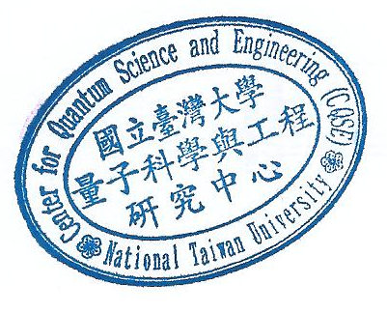
professor with the Broadband Communications Research (BBCR) Group, Department of Electrical and Computer Engineering, University of Waterloo, Waterloo, ON, Canada, a visiting scholar with the Department of Electrical and Computer Engineering, University of Victoria, Victoria, BC, Canada, and a visiting scholar with Graduate School of Information Sciences, Tohoku University, Sandai, Japan. His current research interests include Quantum Computing, Artificial Intelligence, and Internet of Things. Dr. Ou was a recipient of the Lam Research Thesis Award. He is a member of the IEEE, the ACM, and the Phi Tau Phi Honor Scholastic Society.

