Joint CQSE & NCTS Seminar

2024
May 31, Friday

TIME: May 31, 2024, 14:30~15:30 pm
TITLE: Quantification of Photon Fusion for Genuine Multiphoton Quantum Correlations
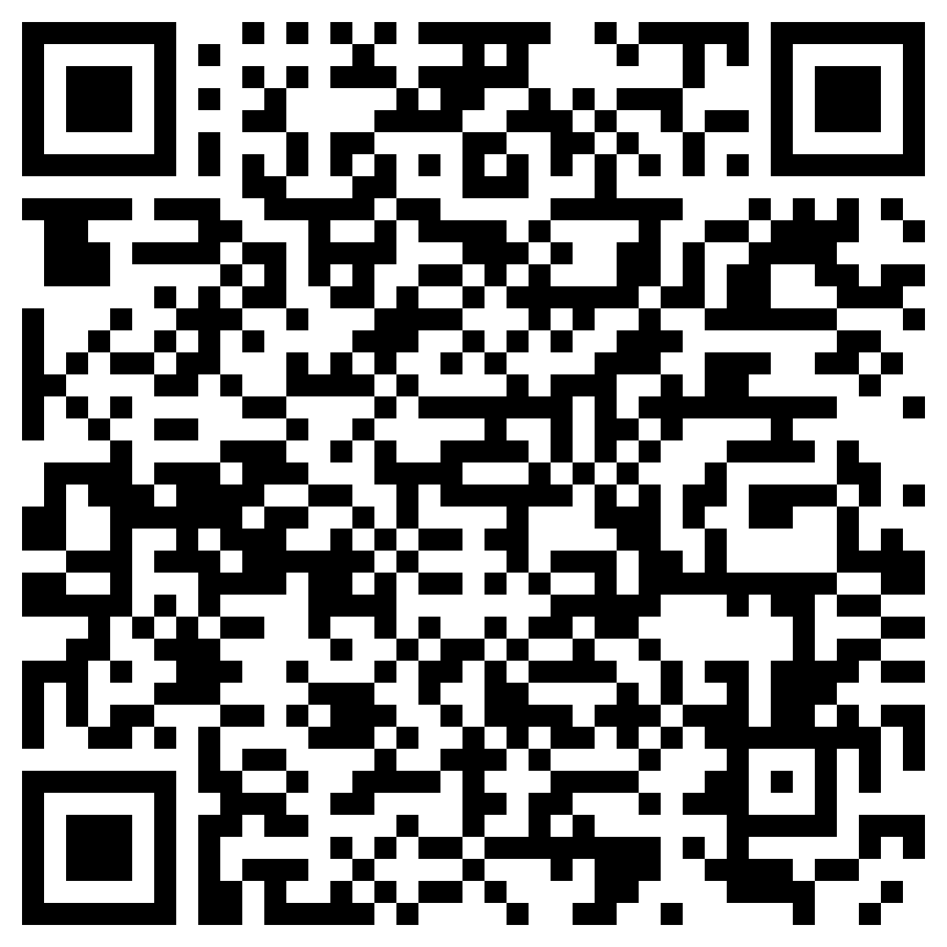
SPEAKER: Prof. Che-Ming Li (Department of Engineering Science, National Cheng Kung University)
PLACE: NCTS Physics Lecture Hall, 4F, Chee-Chun Leung Cosmology Hall, NTU
ONLINE: https://nationaltaiwanuniversity-zbn.my.webex.com/

Abstract:
Fusing photon pairs creates an arena where indistinguishability can exist between two two-photon amplitudes contributing to the same joint photodetection event. This two-photon interference has been extensively utilized in creating multiphoton entanglement, from passive to scalable generation, from bulk-optical to chip-scale implementations. While significant, no experimental evidence exists that the full capability of photon fusion can be utterly quantified like a quantum entity. Herein, we demonstrate the first complete capability quantification of experimental photon fusion. Our characterization faithfully measures the whole abilities of photon fusion in the experiment to create and preserve entangled photon pairs. With the created four- and six-photon entangled states using spontaneous parametric down-conversion entanglement sources, we show that capability quantification provides a faithful assessment of interferometry for generating genuine multiphoton entanglement and Einstein-Podolsky-Rosen steering. These results reveal a practical diagnostic method to benchmark photon fusion underlying the primitive operations in general quantum photonics devices and networks.
Biography:
https://researchoutput.ncku.edu.tw/en/persons/che-ming-li


