Joint CQSE & NCTS Seminar

2024
Apr. 19, Friday

TIME Apr. 19, 2024, 14:30~15:30 pm
TITLE ffsim: faster simulations of fermionic quantum circuits
SPEAKER Dr. Kevin J. Sung (IBM Quantum, IBM T. J. Watson Research Center, IBM)
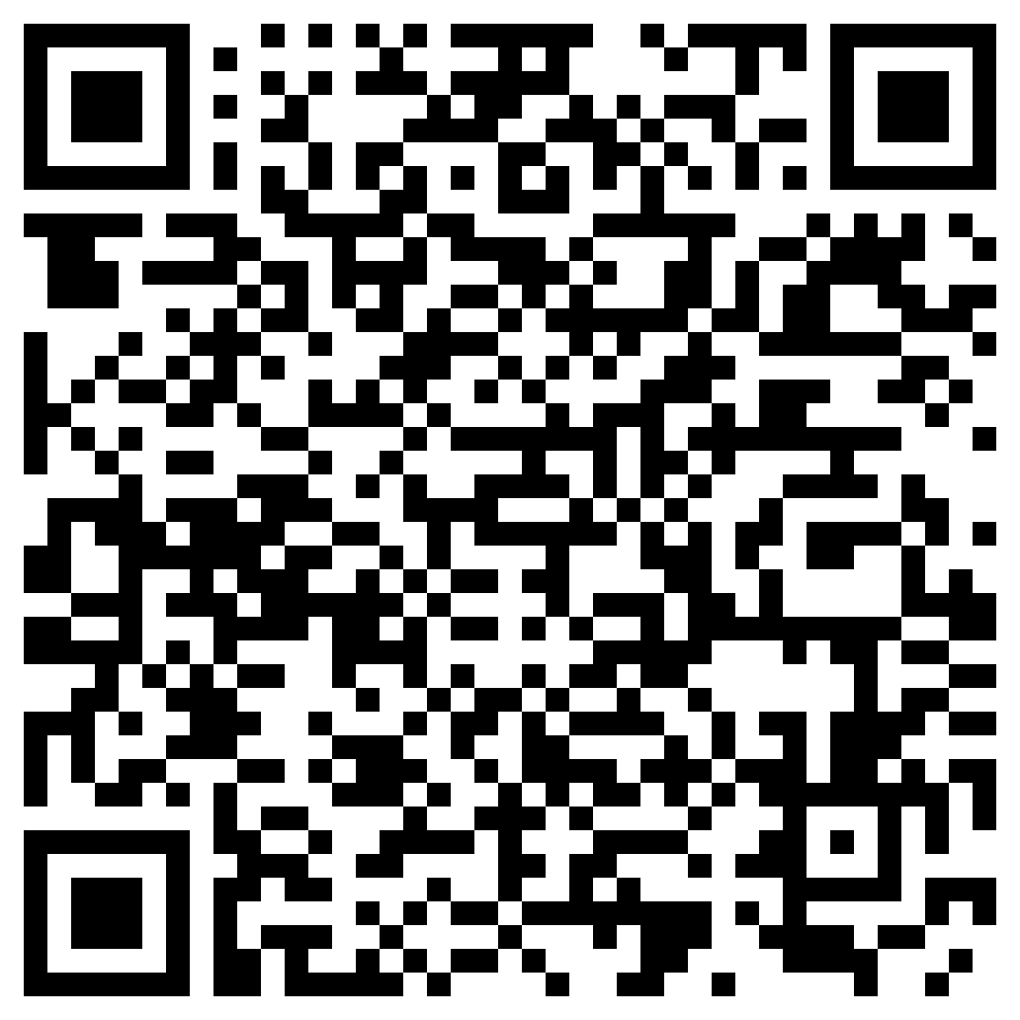
PLACE NCTS Physics Lecture Hall, 4F, Chee-Chun Leung Cosmology Hall, NTU
ONLINE https://nationaltaiwanuniversity-zbn.my.webex.com/

Abstract:
We present ffsim, an open-source software library for simulating fermionic quantum circuits that conserve particle number and the Z component of spin. This category includes many quantum circuits used for quantum chemistry simulations. By exploiting the symmetries and using specialized algorithms, ffsim can simulate these circuits much faster than a generic quantum circuit simulator. The source code of ffsim is available at https://github.com/qiskit-community/ffsim.
Biography:
Kevin J. Sung earned his PhD in computer science from the University of Michigan in 2020. As a PhD student, he investigated the potential applications of near-term noisy quantum computing hardware and developed open-source software for electronic structure applications on quantum computers. After graduating, he joined IBM, where he researches and develops open-source software for quantum computing applications and creates educational content to help users get the most out of IBM's quantum computing services.
