Joint CQSE & NCTS Seminar

2024
Dec. 13, Friday

Time: Dec. 13, 14:20 ~ 16:20
Title: Quantum computing and communication with single photons
Speaker: 褚志崧教授 (Department of Physics, National Tsing Hua University)
Place: Rm. 104, Chin-Pao Yang Lecture Hall, Department of Physics/CCMS, NTU
Online Link: https://nationaltaiwanuniversity-zbh.my.webex.com/nationaltaiwanuniversity-zbh.my/j.php?MTID=m7601bdfa496ccaf8aac2838aab8c25f2

Abstract:
Quantum information processing enables denser encoding, safer transmission, and faster processing of information by harnessing quantum mechanical effects. In this talk, I will talk about how we use the optical approach to realize optical quantum computing and quantum communication.

Biography:
Education
2001.9–2006.12, Ph.D. in Physics, The University of Texas at Austin, USA.
1995.9–1999.6, B.S. in Physics, National Tsing Hua University, Taiwan.
Current position：
2024.08–present, Professor, Department of Physics, National Tsing Hua University, Taiwan
Experience：
2018.2–2024.7, Associate Professor, Department of Physics, National Tsing Hua University, Taiwan
2012.2–2018.1, Assistant Professor, Department of Physics, National Tsing Hua University, Taiwan
2012.6–2012.9, Visiting Scholar, Edward L. Ginzton Laboratory, Stanford University, USA
2008.8–2012.1, Postdoctoral research fellow, Edward L. Ginzton Laboratory, Stanford University, USA.
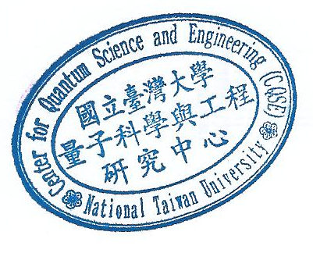
2007.2–2008.7, Postdoctoral research fellow, Institute of Physics, University of Heidelberg, Germany.

