Joint CQSE & NCTS Seminar

2025
March. 7, Friday

Time: March. 7, 14:30 ~ 15:30
Title: Witnessing the Quantum Spin Liquid in Herbertsmithite
Speaker: Dr. Felix Flicker (Senior Lecturer in Condensed Matter Theory at The University of Bristol)
Place: Rm. 104, Chin-Pao Yang Lecture Hall, Department of Physics/CCMS, NTU
Online Link: https://nationaltaiwanuniversity-zbh.my.webex.com/nationaltaiwanuniversity-zbh.my/j.php?MTID=m2a963d31adcf732fcddcf95022ff7210

Abstract:
Herbertsmithite is the leading candidate to host a quantum spin liquid -- a long sought state of matter featuring long-range quantum entanglement and fractionalised 'spinon' excitations. However, despite two decades' work, definitive evidence remains lacking. One complicating factor is that the material features significant disorder in the form of magnetic impurities.
Here we utilise these impurities as 'witnesses' to probe the quantum spin liquid. Using spin noise spectroscopy to measure witness magnetization fluctuations, we find unusual 1/f noise develop below a cusp in DC magnetic susceptibility at 260mK. Ageing effects confirm witness spin glass formation.
I will present a microscopic model of witness interactions mediated by a Z2 quantum spin liquid. Despite having only one free parameter, the model gives a quantitative match to all experiments, including a spin glass transition, the temperature dependence of the susceptibility, the temperature and frequency dependence of the noise spectrum, the Curie Weiss temperature, and the previously observed neutron scattering intensity as a function of momentum transfer.
Biography:
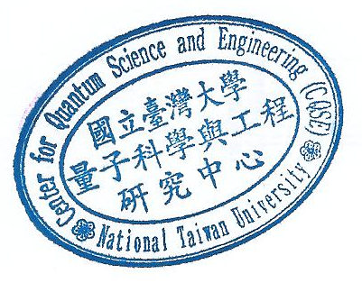
Felix Flicker is a Senior Lecturer in Condensed Matter Theory at The University of Bristol (UK).

