Joint CQSE & NCTS Seminar

2024
Mar. 29, Friday

TIME Mar. 29, 2024, 14:30~15:30 pm
TITLE Bounds on quantum adiabaticity in driven many-body systems and applications to adiabatic quantum computation
SPEAKER Prof. Jyong-Hao Chen (Department of Physics, National Central University)
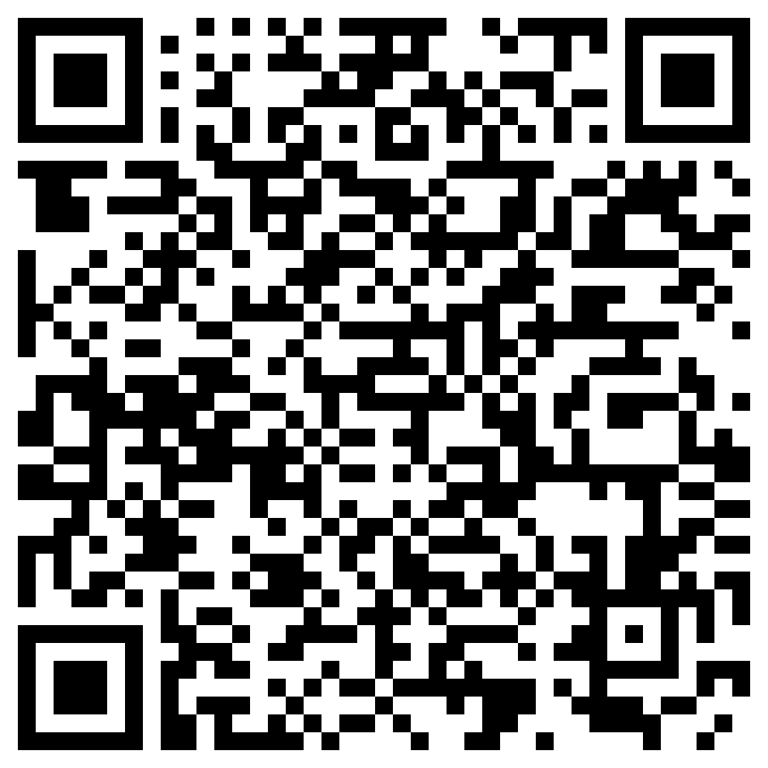
PLACE NCTS Physics Lecture Hall, 4F, Chee-Chun Leung Cosmology Hall, NTU
ONLINE https://nationaltaiwanuniversity-zbn.my.webex.com/

Abstract:
The ability to prepare desired quantum states with high precision is essential in developing contemporary quantum science and technology. To this end, various approximations based on the quantum adiabatic theorem are widely used. However, determining the optimal rate of adiabatic evolution for approaching desired target states is generally a challenging task, particularly in quantum many-body systems. In this talk, I will first explain how one can estimate the quantum fidelity of adiabatic evolution in quantum many-body systems using two more handily calculated quantities: generalized orthogonality catastrophe and quantum speed limit [1,2]. The proposed approach allows us to establish stronger bounds on adiabatic fidelity than those previously obtained in the literature. I will then demonstrate how these new bounds can be applied to adiabatic quantum computing [3]. Notably, our method can provide lower bounds for the runtime of an example of adiabatic quantum algorithms with undetermined quantum speedups (where the traditional approach based on calculating spectral gaps is ineffective).

References:
[1] J.-H. Chen and V. Cheianov, Phys. Rev. Research 4, 043055 (2022).
[2] J.-H. Chen and V. Cheianov, arXiv: 2208.02620 [quant-ph].
[3] J.-H. Chen, Phys. Rev. Research 5, 033175 (2023).

Biography:
Education
- BSc, Department of Physics, National Central University, Taiwan (2005/09 ~ 2009/06)
- MSc, Department of Physics, National Taiwan University, Taiwan (2009/09 ~ 2011/06). Advisor: Prof. Xiao-Gang He
- PhD, Institute for Theoretical Physics, ETH Zurich, Switzerland (2015/02 ~ 2019/05). Advisor: Prof. Christopher Mudry
Experience
- JSPS Visiting Research Fellow, Institute for Solid State Physics, University of Tokyo, Japan (2019/03 ~ 2019/09)
- Postdoctoral Research Fellow, Department of Physics, University of California at Berkeley, the US (2019/10 ~ 2021/08)
- Postdoctoral Research Fellow, Lorentz Institute for Theoretical Physics, Leiden University, the Netherlands (2021/09 ~ 2023/05)
- Postdoctoral Research Fellow, Yukawa Institute for Theoretical Physics, Kyoto University, Japan (2023/06 ~ 2024/01)
- Assistant Professor, Department of Physics, National Central University, Taiwan (2024/02 ~ Present)
Academic Honors
- Yukawa Research Fellow, Yukawa Institute for Theoretical Physics, Kyoto University, Japan (2023/06 ~ 2024/01)
Research Interests
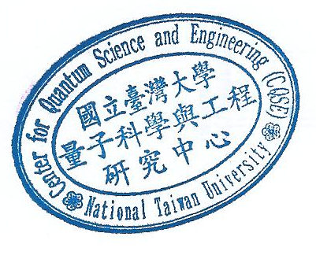
- Condensed Matter Theory, Statistical Physics, Quantum Information Science

