Joint CQSE & NCTS Seminar

2023
Dec. 15, Friday

TIME Dec. 15, 2023, 14:30~15:30 pm
TITLE Quantum Computing and Simulation with Neutral Atoms
SPEAKER Dr. Ying-Cheng Chen (Institute of Atomic and Molecular Sciences, Academia Sinica)
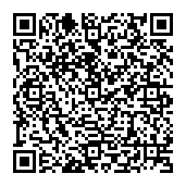
PLACE Rm104, Chin-Pao Yang Lecture Hall, CCMS & New Physics Building, NTU
ONLINE https://nationaltaiwanuniversity-zbn.my.webex.com/

Abstract:
Combining the long coherence time of hyperfine atomic qubits, the strong Rydberg dipolar interactions for qubit entanglement, and the scale up capability using two-dimensional (2D) tweezer arrays for single-atom trapping, neutral atoms have become a versatile platform for the studies of quantum computing and quantum simulation. In the past five years, there have been significant achievements on quantum computing with this platform in the world, e. g. the porotype quantum computer has been demonstrated recently, a two-qubit gate fidelity of 0.995 has been realized, and a qubit number of above 1000 has been prepared. We are developing a 2D single-atom array platform to implement multiqubit digital quantum processor and analog quantum simulator. Our experimental progress will be reported and future studies on the quantum machine learning, quantum approximate optimization, and quantum spin models in this platform will be discussed.
Biography Brief:

Education
- 1997-2002 Ph.D. in Physics, National Tsing-Hua University, Taiwan, Advisor: Prof. Ite A. Yu, Area of study: Quantum optics with ultracold atoms
- 1993-1995 M.S. in Physics, National Tsing-Hua University, Taiwan, Advisor: Prof. Wei-Tou Ni, Area of study: Laser interferometer for gravity test
- 1989-1993 B.S. in Physics, National Tsing-Hua University, Taiwan, Undergraduate project advisor: Prof. Weiyan Guan, Area of study: High- temperature superconductor

Employments
- 2021/10-now, Research Fellow, IAMS, Academia Sincia, Taiwan.
- 2013-2021/10, Associate Research Fellow, IAMS, Academia Sincia, Taiwan.
- 2007-2014, Adjunct Assistant Professor, National Tsing-Hua University, Taiwan
- 2005-2013, Assistant Research Fellow, IAMS, Academia Sincia, Taiwan
- 2003-2004, Postdoctoral Research Fellow, Rice University, Houston, USA, Supervisor: Prof. Thomas C. Killian
- 2002-2003 Postdoctoral Research Fellow, Rice University, Houston, USA, Supervisor: Prof. Randall G. Hulet

Honors and Awards
- The 17th Yu-Ziang Hsu Award on Papers of Science and Technology, 2019.

Research Interests
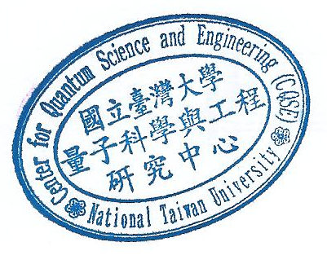
Quantum Optics, Atomic Physics, Quantum Memory, Quantum Computing, Quantum Information Science. Cooperative radiation.

