Joint CQSE & NCTS Seminar

2023
Dec. 08, Friday

TIME Dec. 08, 2023, 14:30~16:00 pm
TITLE Challenges for silicon based quantum computing, from material to system perspective
SPEAKER Dr. Maud Vinet (CEO of Quobly)
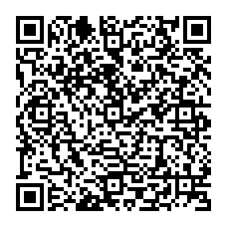
PLACE Rm104, Chin-Pao Yang Lecture Hall, CCMS & New Physics Building, NTU
ONLINE https://nationaltaiwanuniversity-zbn.my.webex.com/

Abstract:
It is now well acknowledged that quantum computing (QC) can extend high performance computing roadmap and this will lead a large value creation in all industry domains, ranging from energy, pharmaceuticals, finance... However, to be a serious contender to classical computers, digital QC will have to perform large number of quantum operations and thus manipulate large numbers of quantum bits. Typically, to solve problems beyond classical computer reach, quantum operations will be over a billion. In this perspective, Si-based quantum computers are a promising approach to build a quantum processor; thanks to the size of the qubits, the quality of the quantum gates and the VLSI ability to fabricate billions of closely identical objects. I will review the current state-of-the-art and present perspectives for silicon to enable quantum advantage, describing challenges to be tackled from material to system integration.
Biography Brief:
Since 2022, Maud Vinet is CEO of Quobly, a start up company which aims at developing and commercializing quantum computers based on silicon.
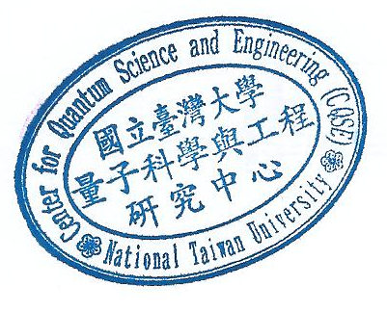
Previously, she led the quantum computing program in CEA Leti. For 20 years she ran technology transfer and development for the semiconductor industry. From 2013 to 2019, she managed the Advanced CMOS activities. From 2009 to 2013, she spent 4 years in Albany (NY, US) to develop Fully Depleted SOI within IBM Alliance together with STMicroelectronics. Maud Vinet authored or co-authored about 300 papers, she owns more than 70 patents related to nanotechnology and her Google h-index is 57 with more than 12000 citations.

