Joint CQSE & NCTS Seminar

2024
Oct. 11, Friday

Time: Oct. 11, 14:20 ~ 16:20
Title: Cryogenic RF Driver Module Design for Superconducting Quantum Computer Application
Speaker: Chang-Sheng Chen 陳昌昇 (Deputy Research Director / Industrial Technology Research Institute)
Place: Rm. 104, Chin-Pao Yang Lecture Hall, Department of Physics/CCMS, NTU
Online Link: https://nationaltaiwanuniversity-zbh.my.webex.com/nationaltaiwanuniversity-zbh.my/j.php?MTID=m7601bdfa496ccaf8aac2838aab8c25f2

Abstract:
A broadband driver module is realized for control of a single transmon Qubit. The driver module comprises a IQ up-conversion mixer designed for operation at 4 K, and is implemented using a 28-nm CMOS process as a prototype for Qubit control. The RF port of the driver module offers the conversion gain of 0.3 ± 3 dB at 4 K over the frequency range of 4 to 10 GHz, with a total DC power consumption of 11 mW. The power handling capability larger than -35 dBm enables to effective driving of the Qubit. The driver module performance is demonstrated through the successful control of a single Qubit. Furthermore, the fidelity of 99.32% is measured by injecting a 4.34-GHz pi-pulse signal with a duration of 20 ns, determined through Rabi oscillation experiments.

Biography:
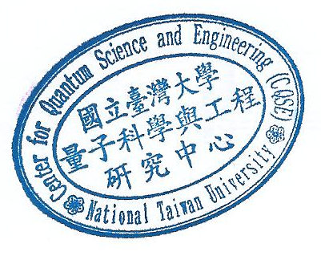
Chang-Sheng Chen is a co-project leader of low-temperature RF circuit for superconducting quantum computer application in ITRI.

